Announcement of the DMZ Docs ‘THE VODA FUND’ Selections
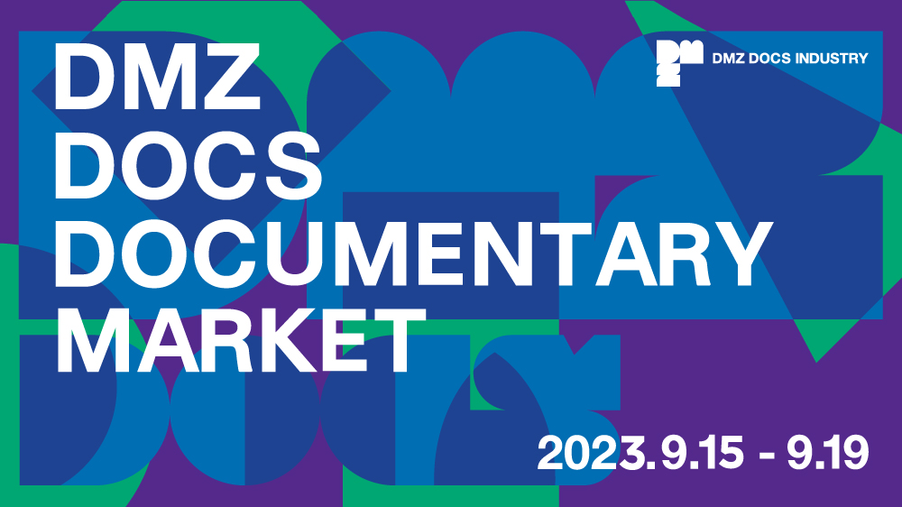
Eight selected projects (4 from Korea, 4 from Asia) will receive the cash grant of KRW 10 million, one individual consulting session, and business meeting opportunities.

The DMZ International Documentary Film Festival (Festival Director Chang Hae Rang, hereinafter DMZ Docs) announced the final selection of eight projects for 'THE VODA FUND'. The festival aims to promote the values of peace, communication, and life through documentaries.

'THE VODA FUND' is a production support fund that targets feature-length and mid-length documentary projects in the planning and early production stages, aiming to remind audiences of the documentary genre's role as the most optimized medium for observing, documenting, and presenting the world. It was previously known as the ‘Development Fund’, but underwent a name change for this purpose. The submission period took place from March 6 to April 3, with a total of 71 submissions received. Eight projects have been selected after being reviewed by a panel of documentary experts.

The review of submissions was conducted separately for Korean and Asian projects. The Korean projects were assessed by Director OH Junghun, Director JEONG Jae-eun, and Sunah KIM, DMZ Docs Industry Producer. The Asian projects were evaluated by Sunhee HAN Producer, Asako Fujioka, YAMAGATA International Documentary Film Festival Board of Directors, and KANG Jinseok DMZ Docs Programmer.

The selection committee members for Korean project stated, “We selected films based on the director's clear vision, evidence of new facts, intriguing narrative construction, and unique expressive world.". They also added to express their support, “These films will provide us, who are living in the present, with new awareness and introspection. They will enable us to approach the issues faced by Korea and the world, sometimes from a micro perspective and sometimes from a macro perspective. Above all, we will encounter documentaries that are profound and captivating.".

The selection committee members for Asian project stated, “It reflected the goal of the festival to focus on lesser-known Asian documentary projects and promote their international exposure. The projects covered a wide range of topics, including personal exposes, historical investigations, political movements, and stories of growth. Various approaches, such as hybrid formats and experimental attempts, stood out as well.".

Each project selected for 'THE VODA FUND' will receive the cash grant of KRW 10 million, along with individual consulting session and business meeting opportunities during the 2023 DMZ Docs Documentary Market.

The 15th DMZ International Documentary Film Festival will be held from September 14 to September 21, 2023 and DMZ Docs Documentary Market will be held from September 15 to September 19, 2023, at Paju-si and Goyang Special City, Gyeonggi-do.

