DMZ Docs Documentary Market Calls for Pitch Entries
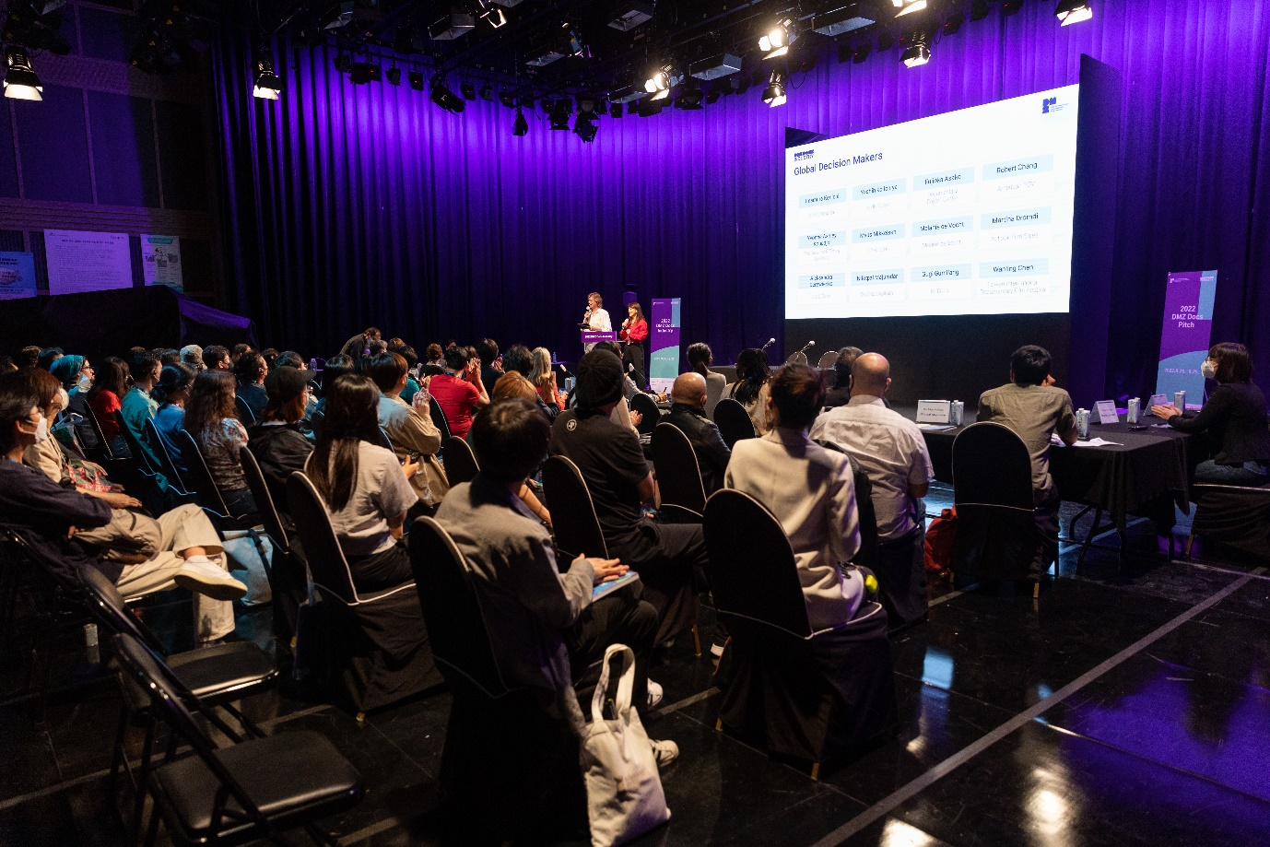
Submissions for Global Pitch and Rough Cut Pitch opened on May 22

[Photo of 2022 DMZ Docs Pitch Event]

The DMZ International Documentary Film Festival (Festival Director Chang Hae Rang, hereinafter DMZ Docs) aims to promote the values of “Peace, Life, and Communication” through documentaries, and its Pitch Program submissions opened on May 22.

Since its establishment in 2019, DMZ Docs Industry has managed a documentary market which discovers outstanding documentary projects, trains people, secures production costs, and expands opportunities for domestic and global distribution. It also encourages networking between documentary creators and promotes the global expansion of documentaries made in Korea.

DMZ Docs Pitch is a competition-based program that discovers Korean and Asian documentary projects with strong global appeal. For documentary creators who are producing meaningful documentaries in tough environments, the DMZ Docs Pitch provides invaluable opportunity to receive mentoring and workshop from global industry experts and network with possible buyers, investors, festival programmers, and sales agents. The Pitch also offers prize money and various in-kind awards to the Pitch winners.

The DMZ Docs Pitch has two categories : “Global Pitch” for projects in production, as of September 2023 and “Rough Cut Pitch” for projects in editing stage.

The projects must be submitted online at the DMZ Docs Industry website. For details, please refer to the DMZ Docs Industry website (https://industry.dmzdocs.com/eng/).

The 15th DMZ International Documentary Film Festival will be held from September 14 to September 21, 2023 and DMZ Docs Documentary Market will be held from September 15 to September 19, 2023, at Paju-si and Goyang Special City, Gyeonggi-do.

