14th DMZ International Documentary Film Festival Press Release
Dept. in Charge | Promotion and Marketing Team marketing@dmzdocs.com
Available Release Date | Available Immediately
Announcement on Winners of 2022 DMZ Docs Industry
Cash Prize and In-kind Support for Winners
Completed 6 Days of Journey after Awards Ceremony in 25th of September
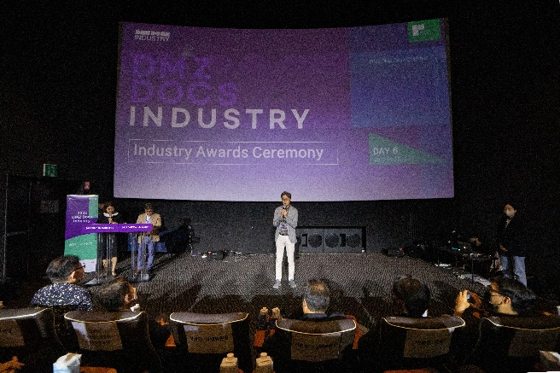 | 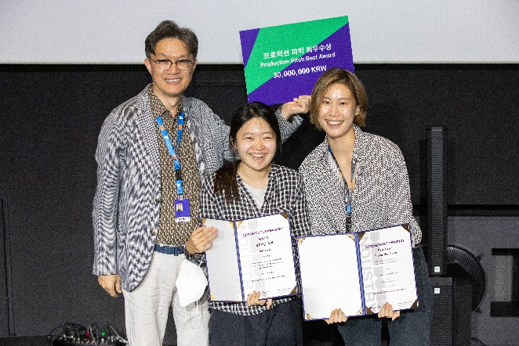
2022 DMZ Docs Industry Awards Ceremony

DMZ Docs Industry is a documentary industrial platform that discovers outstanding documentary projects and supports documentarians in Korea and Asia. DMZ Docs Industry was held under the theme “Dream what it should be” and completed its 6 days of journey with the Industry Awards Ceremony on September 25.

The awards ceremony held in September 25 announced the award winners for diverse fields, including cash prizes and in-kind prizes for the DMZ Docs Pitch winners and K-Doc Short Pitch winners. DMZ Docs Pitch winners won the production funds in cash and in-kind around 195 million KRW, while K-Doc Short Pitch winners won the funds of 150 million KRW sponsored by the Korea Creative Content Agency.

In the Production Pitch for the Korean and Asian projects, Colors of the Wind(working title) and Devi won the Best Award and received 30 million KRW respectively. Moment of a Star and Our Hoolocks won Excellence Award with 20 million KRW prize money, and 1997, Grounding, A Woman’s Path, and First Fairytale Book won the Special Jury Awards with 10 million KRW per project.

In the Rough Cut Presentation category, Concrete Land won the Best Award with the cash prize of 25 million KRW, and My Missing Aunt and Ininnawa: An Island Calling won the Excellence Award with 15 million KRW per project.

In the K-Doc Short Pitch Category, My Body My Proof and Sound of Silence won the Grand Prize. Mystery F. File, Missed Call (working title), Soonja and I, Kintsugi, and The Rest Stop won the Best Prize. Furthermore, 8 projects including Sometimes the Way is Beautiful (working title) won the Excellence Prize.

A Warm Welcome won the SBA Award that supports the whole post-production stage and 1997 won the Feel&Plan Award that supports the promotional marketing for releasing in the theaters.

IDFA Spotlight Award went to a Korean project, Grounding, Hot Docs Industry Award was given to a Korean project Guest Workers, and Docedge Kolkata Award went to a Korean project Colors of the Wind (working title) and a Chinese project The Wild Street.

DMZ International Documentary Film Festival leads on spreading the values of “Peace, Life, and Communication” and it will be held until September 29 at Goyang-si and Paju-si, Gyeonggi-do.

*Attachment

2022 DMZ Docs Industry Award Winners
Sector | Award Sector | Title
Production Pitch | Best Award | Colors of the Wind(Working Title)
 |  | Devi
 | Excellence Award | Moment of a Star
 |  | Our Hoolocks
 | Special Jury Award | 1997
 |  | Grounding
 |  | A Woman`s Path
 |  | First Fairytale Book
Rough Cut Presentation | Best Award | Concrete Land
 | Excellence Award | My Missing Aunt
 |  | Ininnawa: An Island Calling
K-Doc Short Pitch | Grand Prize | My Body My Proof
 |  | Sound of Silence
 | Best Prize | Mystery F. File
 |  | Missed Call (Working Title)
 |  | Soonja and I
 |  | Kintsugi
 |  | The Rest Stop
 | Excellence Prize | Sometimes the Way is Beautiful (Working Title)
 |  | To Road To Race Track
 |  | Mee(a)t Papa
 |  | Letters from Our Places
 |  | Medical Refugees
 |  | The Story of the Nameless
 |  | Diarist
 |  | Women of the Head Family ‘Jong Ga’
Industry In-Kind Support | SBA Award | A Warm Welcome
 | Feel&Plan Award | 1997
 | Docedge Kolkata Award | Colors of the Wind (Working Title)
 |  | The Wild Street
 | IDFA Spotlight Award | Grounding
 | Hot Docs Industry Award | Guest Workers

