14th International Documentary Film Festival Press Release
Dept. in Charge | Promotion and Marketing Team marketing@dmzdocs.com
Available Release Date | Available Immediately

Announcement of 32 Projects for “DMZ Docs Industry” Funds

121 Projects Submitted from 29 Asian Countries This Year
Customized Supports with Production Funds and In-kind Supports for Each Production Stage
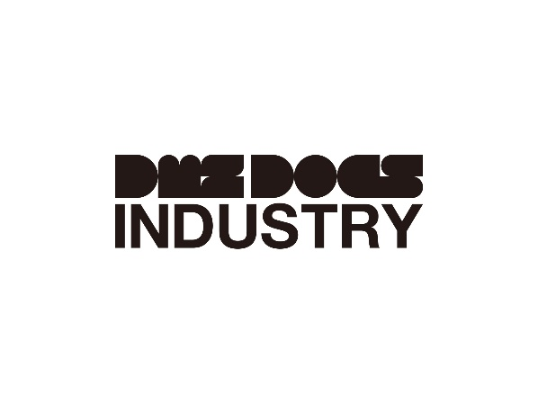
DMZ Docs Industry Logo

DMZ International Documentary Film Festival (Head of Organizing Committee : Dong-yeon Kim, Head of Executive Committee : Sang-jin Jung) (hereinafter “DMZ Docs”) has been discovering excellent documentary projects and supporting them domestically and internationally. DMZ Docs announced 32 documentary projects for this year’s DMZ Docs Industry Fund Program.

DMZ Docs Industry is the largest Asian documentary project platform that discovers the documentary films in planning and production stages and supports the filmmakers in Korea and other Asian countries. DMZ Docs Industry grows together with the documentarians to offer various customized supports for each production stage.

The 32 Projects selected for DMZ Docs Industry Fund Program are currently in the early production stage and post-production stage. Among them, 18 Korean Projects are selected for “Research Fund” with funding of 2,000,000 won respectively and 6 Korean Projects and 6 Asian Projects are selected for “Development Fund” with funding of 10,000,000 won respectively. In addition, 2 Korean films that are parts of the DMZ Docs Film Festival Official Selection are selected for “Post-Production Support” with in-kind supports.

Total of 121 projects were submitted from 29 Asian countries including Korea for this year’s DMZ Docs Industry Fund Program showing the undying passion for recording the documentary even in the global crisis of COVID-19 pandemic and the war situation. Especially, some of this year’s projects tend to look into the society in large and provide deep insights into the humanity by telling the stories of the filmmakers and/or their closest family members.

Jung who is the head of Executive Committee commented “I’d like to congratulate all the selected projects for this year’s DMZ Docs Industry Fund Program. DMZ Docs Industry will continue to support the documentary filmmakers actively to promote positive impacts of documentaries.”

DMZ International Documentary Film Festival promotes the values of “Peace, Life, and Communication” with documentaries and celebrates its 14th anniversary this year. The 14th DMZ International Documentary Film Festival will be screening about 130 documentaries from September 22 to September 29 at Goyang-si and Paju-si, Gyeonggi-do. DMZ Docs Industry will be held at Goyang-si from September 20 to September 25.

> Research Fund
18 Projects (Korean only)

> Development Fund

Korea
Project | Director | Country
Iron Lady | lee Ilha | Korea
Red Diary | lim Daecheong | Korea
Knot | Ryu Hyungseok | Korea
Our Bodies | Lee-kil Bora | Korea, Netherlands
After Life | Kim Jeongkeun | Korea
Adulting Time | Lee Heewon | Korea

Asia
Project | Director | Country
Breaking the Wall | weichao Xu | China
The Father, The Son and The Son's Daughter | Pankaj Johar | India
KOCHKASHI | Nazila Ahmadi | Afghanistan
Magnetic Letters | Demie Dangla | Philippines
Tens Across the Borders | Sze-Wei Chan | Singapore, Philippines
Virtues in Village | Meng Han | China

> Post-production In-kind Support
Korea
Project | Director | Country
Until the Stones Speak | KIM Kyungman | Korea
Time of Seeds | SEOL Suan | Korea

