14th DMZ International Documentary Film Festival Press Release
Dept. in Charge | Promotion and Marketing Team marketing@dmzdocs.com
Available Release Date | Available Immediately
14th DMZ International Documentary Film Festival
Announcement of 23 Pitch Projects for “DMZ Docs Industry”

Opportunity to Join Award Pitch & Win Production Funds
Outstanding Performance of New Directors & Female Directors in 2021 and 2022
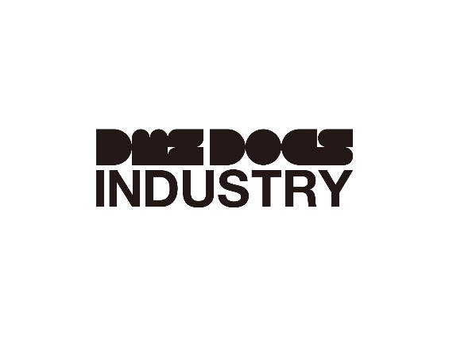
△ DMZ Docs Industry Logo
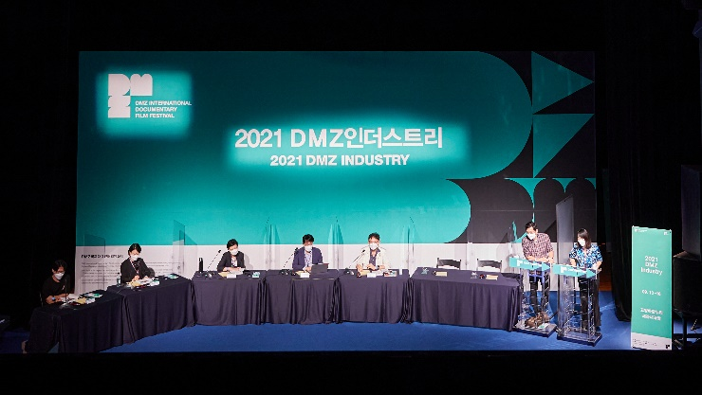  △ Photo of 2021 DMZ Docs Industry  (DMZ Docs Pitch) | 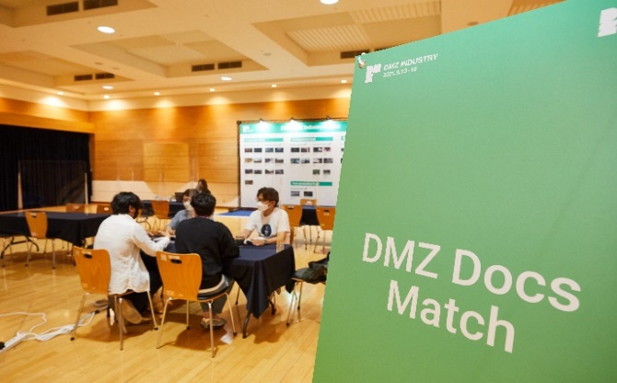  △ Photo of 2021 DMZ Docs Industry  (DMZ Docs Business Meeting)

Celebrating its 14th anniversary this year, DMZ International Documentary Film Festival (Head of Organizing Committee: Dong-yeon Kim, Head of Executive Committee: Sang-jin Jung (hereinafter “DMZ Docs”) announced 23 pitch projects for DMZ Docs Industry which will be held in upcoming September.
DMZ Docs Industry is the largest Asian industrial platform that discovers the documentary films in planning and production stages and supports the creators in Korea and Asian countries. DMZ Docs Industry grows together with the creators to offer various customized supports.

From September 20 to 25, the projects will be participating in Industry Award Pitch with prizes in cash and in-kind supports as well as having business meetings with Korean and foreign industry professionals.

Among the selected 23 projects, 15 projects are by new directors while 12 projects are by female directors. This clearly shows the outstanding performance of female directors and new directors in 2021 and 2022.

In addition, DMZ Docs Industry hosts “K-Docs Short Pitch” for short- and medium-length documentary projects in collaboration with The Korea Creative Content Agency (KOCCA).

DMZ Docs Fund applications are currently in consideration. Its result will be announced by early August.

Jung who is the head of Executive Committee said “DMZ Docs is a partner who whole-heartedly helps the documentary creators by holding film festivals, screening excellent Korean and foreign documentaries, and supporting the documentaries in the production stage. DMZ Docs Industry will try its best to continue and expand the good influences of documentaries that record the contemporary times.”
DMZ International Documentary Film Festival spreads the values of “Peace, Life, and Communication” with documentaries and it celebrates 14th anniversary this year. 14th DMZ International Documentary Film Festival will be screening about 130 documentaries from September 22 to September 29. DMZ Docs Industry will be held from September 20 to September 25.

*Refer to the following table for list of projects for 2022 DMZ Industry Pitch.

List of Projects for 2022 DMZ DOCS Industry Project Pitch
◆ Production Pitch, Korea
 | Title (Korean Alphabetical Order) | Director | Country of Production
1 | 1997 | TAE Junsik | Republic of Korea
2 | DON | SUN Hobin | Republic of Korea
3 | Colors of the wind | LEE Yeojin | Republic of Korea
4 | Moment of a Star | JANG Hyobong | Republic of Korea
5 | Song from Deaf Butterfly | HYUN Jinsik | Republic of Korea
6 | Guest Workers | LEE Sanhah | Republic of Korea
7 | Grounding | MA Minji | Republic of Korea
8 | Living Across the Blue Roof | AHN Soyon | Republic of Korea

◆ Production Pitch, Asia
 | Title (Alphabetical Order) | Director | Country of Production
1 | Devi | Subina Shrestha | United Kingdom, Nepal
2 | Dreams of a Dark Sky | Anmol Tikoo | India
3 | First Fairytale Book | ABM Nazmul Huda | Bangladesh
4 | Our Hoolocks | Ragini Nath,  Chinmoy Sonowal | India
5 | Ta-thung: Between Two Worlds | Ismail Fahmi Lubis | Indonesia
6 | These Legs Are Made For Walkin' | Herbert Hunger | Japan
7 | THE WILD STREET | Lucy Huang | China
8 | A Woman's Path | Marjan Khosravi | Iran, Spain

◆ Rough Cut Presentation, Korea
 | Title (Korean Alphabetical Order) | Director | Country of Production
1 | My Missing Aunt | YANG Juyeon | Republic of Korea
2 | A Warm Welcome | PARK Marisol | Republic of Korea

◆ Rough Cut Presentation, Asia
 | Title (Alphabetical Order) | Director | Country of Production
1 | Al Awda | Jason Soo | Italy, Israel, Palestine, Lebanon
2 | Close To The Bone | Katsuya Okuma | Japan
3 | CONCRETE LAND | Asmahan Bkerat | Jordan
4 | Ininnawa: An Island Calling (Former Title: Rabiah & Mimi) | Arfan Sabran | Indonesia
5 | Toward Happy Alleys | Sreemoyee Singh | India

